

**SUMMER SEMESTER 2024**

**APT3090 CRYPTOGRAPHY AND NETWORK SECURITY**

**Joy Kirui-664830**

**Write a program using any Object oriented programming language to show implementation of RSA. The input p and q should be generated by randomly (15 Marks)**

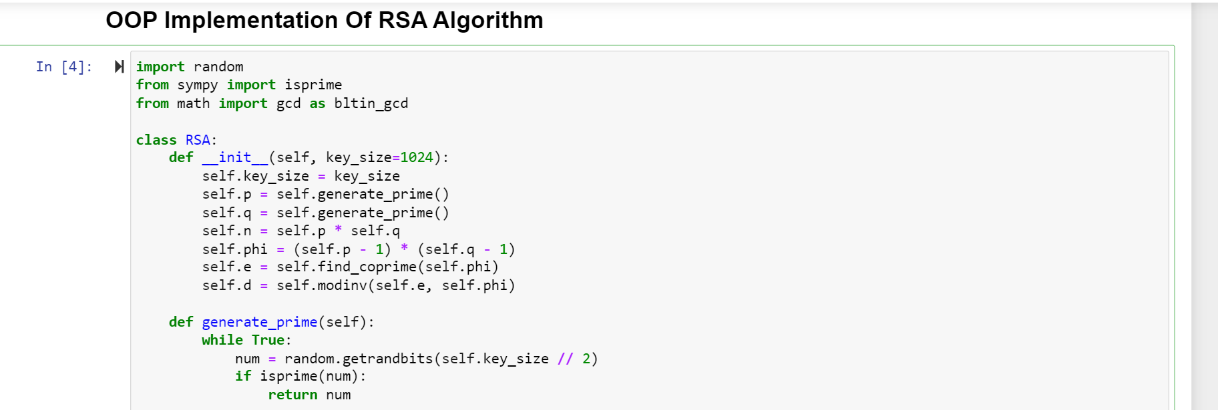

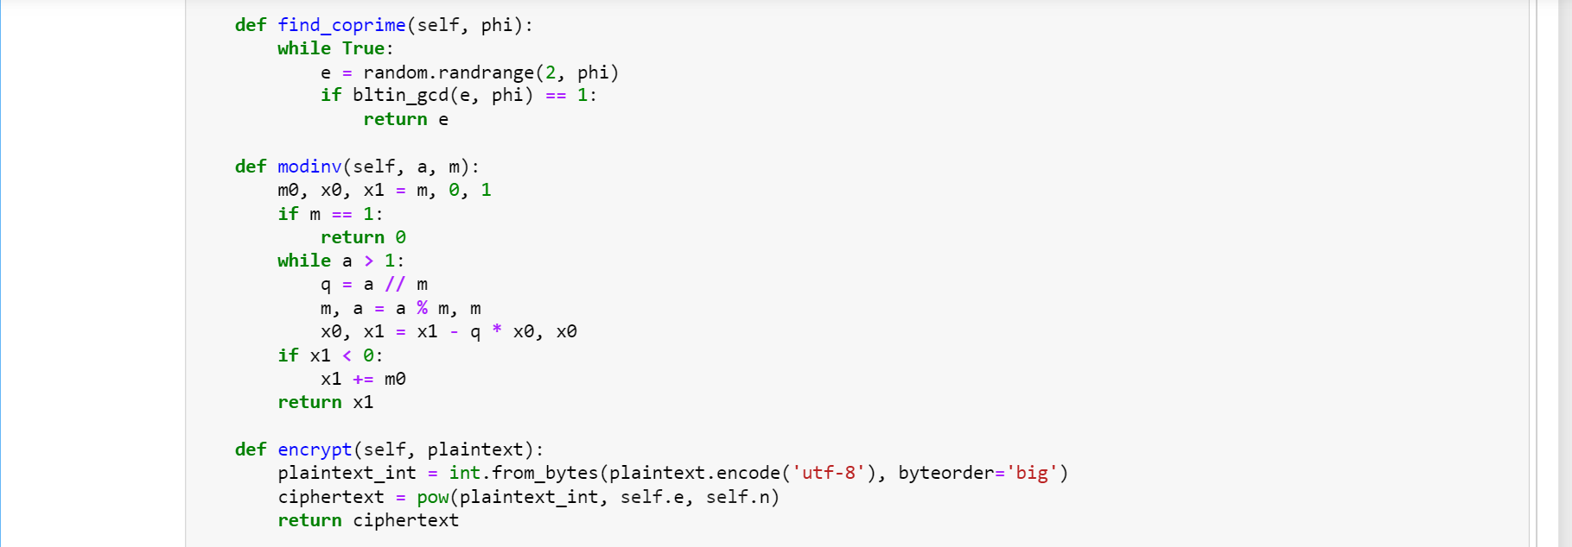

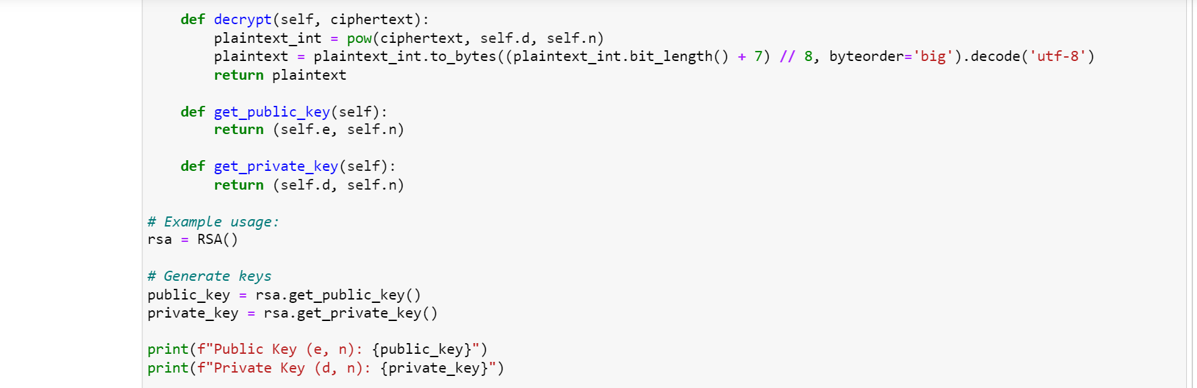

• **Initialization of Class (__init__)**: It initializes the RSA object with a key size, then generates two prime numbers ppp and qqq, calculates nnn and ϕ(n)\phi(n)ϕ(n), and generates the public and private keys eee and ddd respectively.

• **Random Generation of Prime (generate_prime)**: It generates a random prime number of specified bit size.

• **Finding the CoPrime (find_coprime)**: Finds a coprime integer eee to ϕ(n)\phi(n)ϕ(n).

• **Inverse of the Modular (modinv)**: Calculates the inverse of the modular of eee under modulo ϕ(n)\phi(n)ϕ(n).

• **The Encryption (encrypt)**: It converts a plaintext message to its integer representation, then encrypts it using the public key.

• **The Decryption (decrypt)**: It decrypts the integer ciphertext back to the plaintext message using the private key.

• **The Retrieval of the Key (get_public_key, get_private_key)**: It retrieves the public and the private keys.

## Results

In this scenario, Alice is sending Bob a message. The message is encrypted using the two randomly generated numbers p and q. The private key of Alice is generated and the shared public key is also generated.

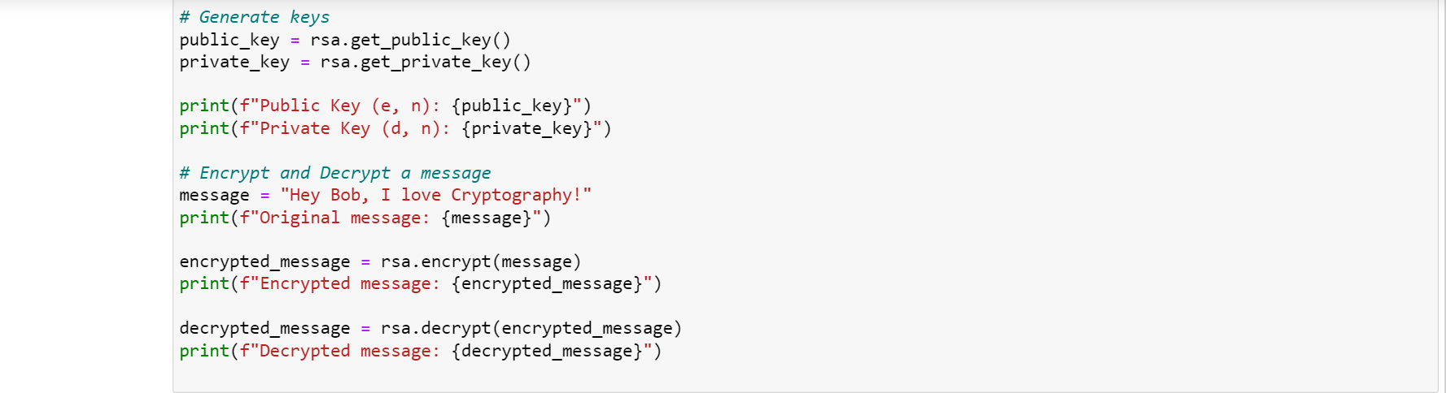

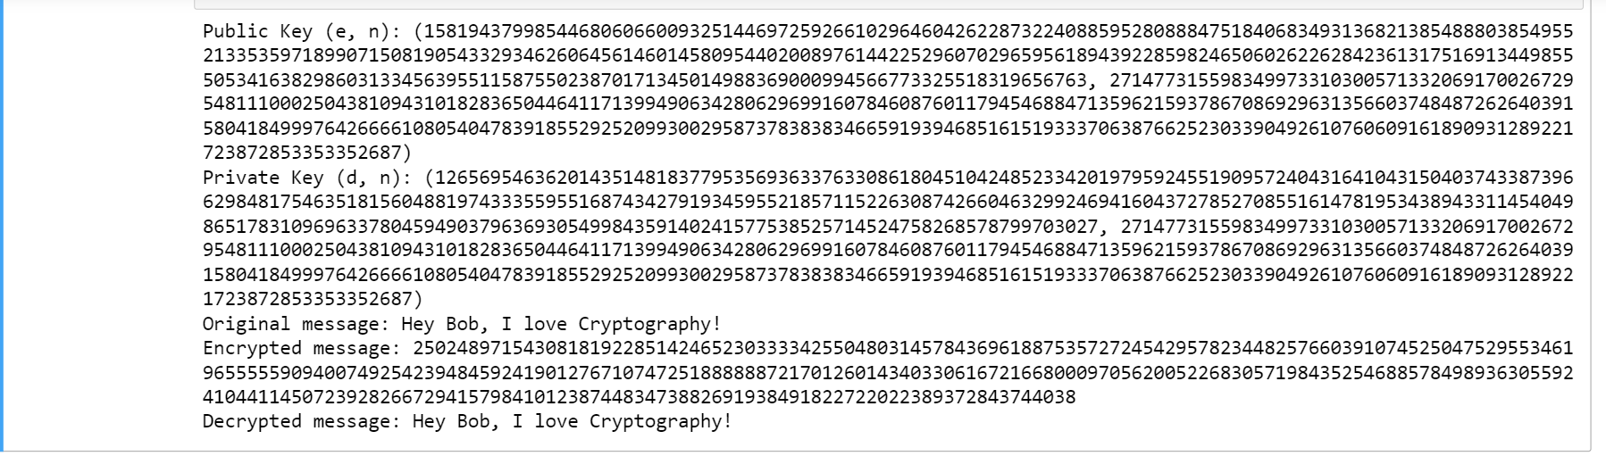

## Second Scenario

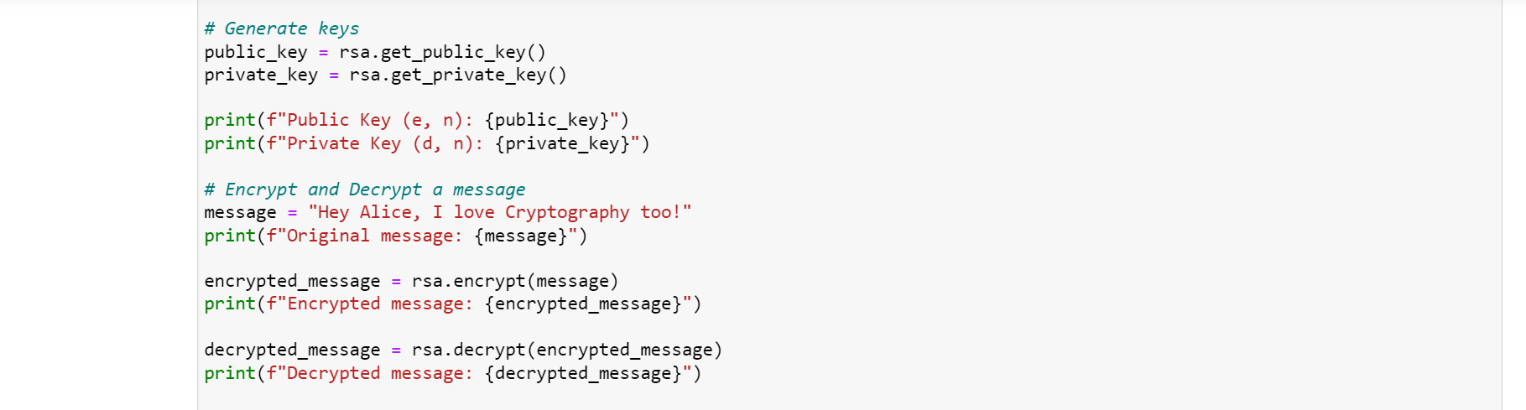

Here Bob is replying to message is encrypted using the two randomly generated numbers p and q. The private key of Bob is generated and the shared public key is also generated.

